**Project Development Phase**

**Model Performance Test**

|  |  |
| --- | --- |
| Date | 16 November 2022 |
| Team ID | Team-592275 |
| Project Name | Gilded Emotions: Unearthing Market Sentiments In Gold News |
| Maximum Marks | 10 Marks |

**Model Performance Testing:**

Project team shall fill the following information in model performance testing template.

|  |  |  |
| --- | --- | --- |
| **S.No.** | **Parameter** | **Screenshot / Values** |
|  | Dashboard design | No of Visualizations / Graphs - SVM and Logistic Regression Performance Metrics[SC-1,2,3,4,5—from the next page] |
|  | Data Responsiveness | SVM: 0.89, Logistic Regression: 0.88 |
| 3. | Amount Data to Rendered (DB2 Metrics) | SVM: Confusion Matrix, Metrics; Logistic Regression: Confusion Matrix, Metrics |
| 4. | Utilization of Data Filters | SVM and Logistic Regression models |
| 5. | Effective User Story | No of Scene Added – N/A |
| 6. | Descriptive Reports | No of Visualizations / Graphs - SVM and Logistic Regression Metrics |

[SC-1]

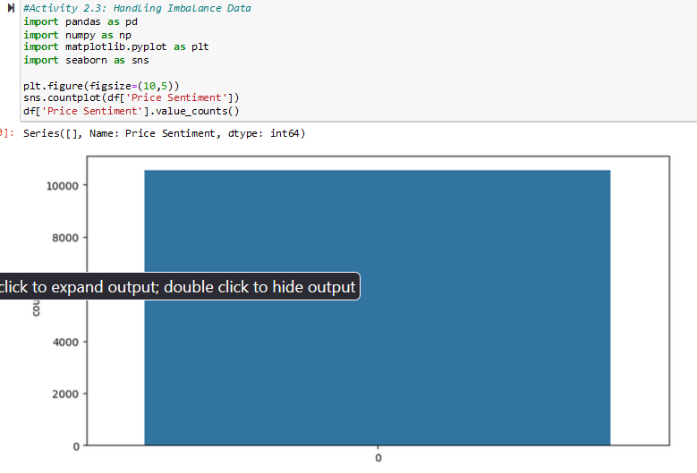

[SC-2]

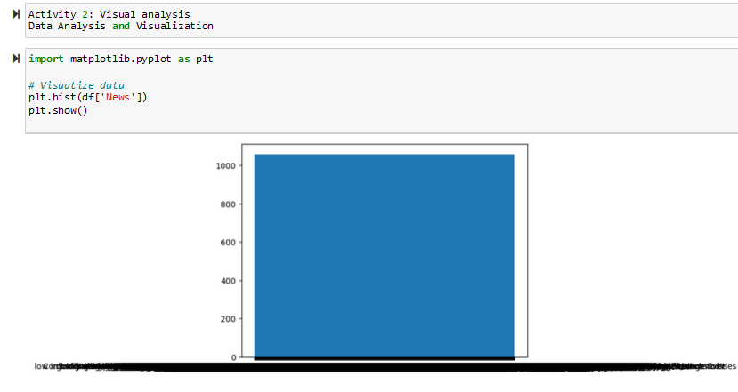

[SC-3]

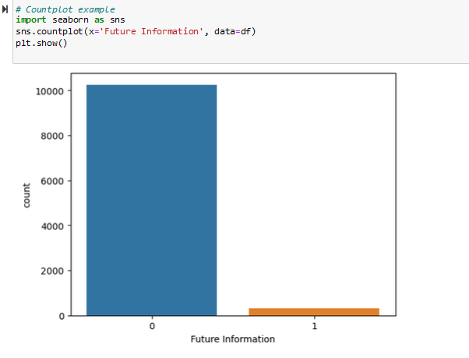

[SC-4]

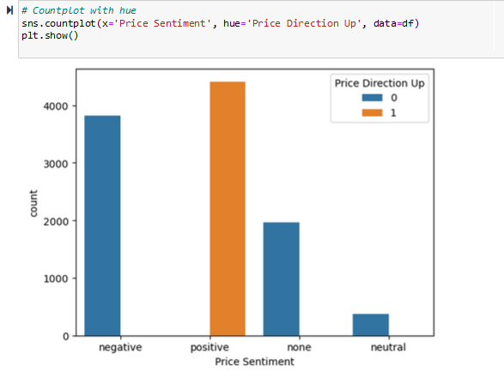

[SC-5]

